Discussion 4
The image I have chosen for this discussion is Figure 1.8, a painting depicting ropes tied into knots on the second page of the chapter. The painting is associated with South America's Inca society who used this form of communication in the 5th and 6th centuries. The Inca society kept records and communicated using an arrangement of knots and colored threads called quipu that possessed distinctive meaning. They used this means of communication because they had no written language (Openstax, n.d).
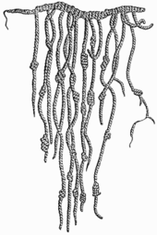
Figure 1.8 Quipu.
Benjamin Franklin's autobiography reflects the 18th century as that of idealism and the era of reason because intellectualism thrived along with scientific discoveries. Benjamin mentions that he longed to go to the sea and disliked chandler’s trade. He excelled in water sports, although there was a time that he led his playmates into trouble because of such interests. Additionally, he says that during that period, the strolls' experience with his father around Boston was helpful to him later since he learned how to perform small jobs alone, something that would be useful later in his experiments (Franklin, 2007).

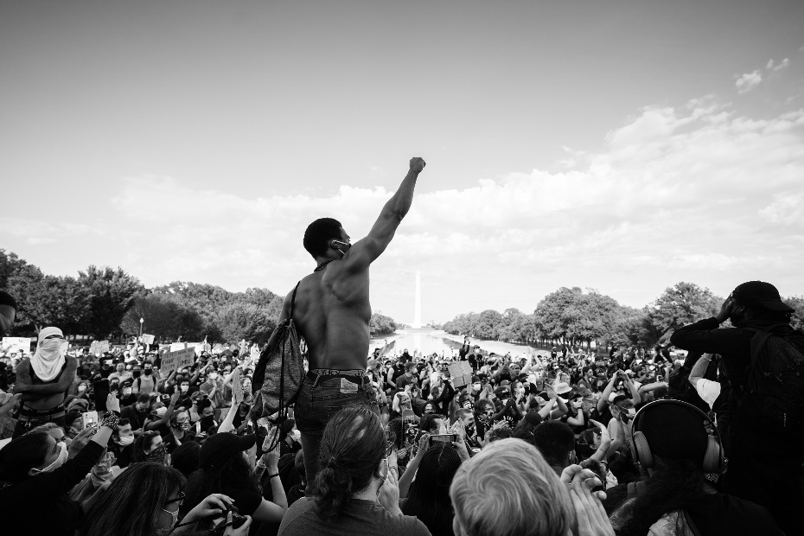
Figure 2: Black Lives Matter Demonstrations.
I think that the above image will affect the previous racial injustices that have been witnessed in the United States. This picture depicts a fight for freedom and protection of civilian rights and lives. Nonetheless, the revolution already began with the election of a new government. Thus I believe that history will not repeat itself moving forward. Lastly, the image serves as a reminder of pain and suffering, which ought not to reoccur in the future (Garza, 2014).
Discussion 5
One battle that was fought during the American Revolution was the Virginia campaign. It was a series of army tactics and battles that led to Yorktown's conclusive restriction in October 1781. The campaign led to the submission of the British military general Charles Cornwallis. General George Washington led the Virginia campaign battle.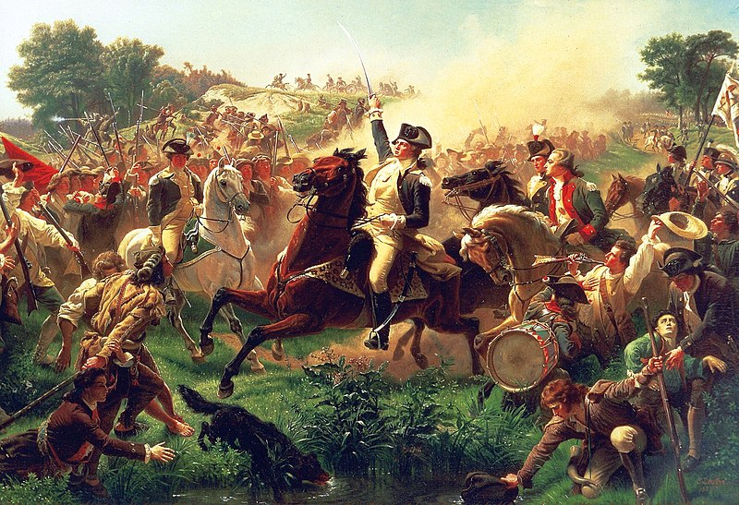
Figure 3: The Battle of Monmouth, 28th June 1778 by Emanuel Leutze.
The above painting depicts General George Washington rallying troops at Monmouth. Monmouth battle was the final encounter of the Philadelphia campaign that begun the preceding year, through which the British had caused two main victories against George and occupied Philadelphia. As shown in this image, my understanding of the American Revolution marks a transition that met with uncertainty and executed cruelly. There are innocent individuals depicted in the painting who are not armed and are running away (Bilby & Jenkins, 2010).
The history of the American Revolution does prove that owning small firearms is a way for citizens to defend themselves against tyrannical governments. However, that is not the case now. Currently, the second amendment functions are violated by restrictions; thus, people cannot defend themselves against tyrannical regimes. Some of the restrictions are, hidden carry limitations, gun tracing with a national database of individuals owning guns, and licensing requirements for gun possession.
Discussion 6
Last year's police brutality cases, especially on black Americans, lead to the famously known black lives matter movement. According to Garza (2014), the movement aimed to create awareness and protect oneself against police brutality. Just like any other American citizen, I decided to film police encounters for my safety. On one particular occasion, I got detained by an officer who cited me for filming on a private where I was filming on a public sidewalk. I explained that I was exercising my first amendment, which was freedom of the press meaning anyone could record without a press card since the bill of rights defends the act. However, my detainment was illegal because the officer had no probable cause of detaining me since I had not committed a crime or was going to commit a crime. I decided then to ask for a supervisor because the officer was misinformed and did not know how to perform his duties. Similarly, I chose to invoke the Fifth Amendment right to remain silent until the supervisor came so that I could settle my case.
The US Constitution manifests the ideologies of both democratic and republican administration forms by encouraging an illustrative democracy. Most federal officials are not elected directly. The formula specified by framers was that voters hold power. Thus, power trickles upwards from them. In this case, this is done by certain representation means and direct voting.
I do not think that allowing states to authorize marijuana for limitless use even if the federal government considers it illegal will only encourage rot within the society. Similarly, this should not be allowed to discourage gang-related violence since drugs and violence are inseparable. Additionally, states should discourage the legalization of marijuana for it is addictive and the dependence on the drug will rise with its legalization. Lastly, legalizing marijuana is opposed by main public health organizations.
Discussion 7
I agree that Benjamin Franklin possessed wisdom and common sense from an early age because he was fascinated by lifelong learning and reading. Secondly, he had the spirit of self-improvement. At the tender age of 12, he was his brother's apprentice. Lastly, Franklin was a hard worker and credited most of his productiveness success (Franklin, 2007).
According to the National Archives (n.d), new technologies like railroad lines, canals, and steamship brought a transportation revolution. Artificial rivers could save travelers immense amounts of money and time, thus improving the United States economy. Railroads improved the economy because as soon as the rail grid began to take shape, there was greater demand for steel, iron, and coal. Shortly, both canals and railroads crossed the states, providing a transport medium that fueled the American economy's growth. Later on, the revolution in transport led to iron, steel, and coal industries, leading to the emergence of new job opportunities.
Although other individuals would argue that attempting to get Asian or African nations to become part of the United States would increase their resources, I do not think it is necessary. The reason being that the United States has a robust economy capable of sustaining its citizens. Furthermore, the immigrants' issue is enough baggage for the country; adding other continents would mean even more pressure. Lastly, expanding the boundaries would possibly lead to scarce resource allocation.
Discussion 8
My utopia would be called Sun Fields in the state of Texas. We would mainly make our living from farming and livestock rearing. Our policy on children would be that all children belong to the community; thus, anyone can perform disciplinary actions. Besides, marriage would be considered sacred in our policy and divorces would be discouraged for the children’s sake. We would erect perimeter walls around our community and also encourage strong male individuals to take up the duty of ensuring the community’s safety. On the other hand, the type of governance we would adopt is an oligarchy, which means governance by a select group of individuals. Our religious beliefs would be offering sacrifices in the form of harvests to the God in the sky.
Discussion 9
I believe that the United States was justified in pursuing the Mexican war because Mexico had poured American blood on American soil. Most Mexicans considered Texas their own. However, Texas was a self-governing republic and had the right to rule itself. With this effect, Texas tried to be part of the United States, meaning that the United States had to be involved in the war. The death of sixteen Americans on the Texan Mexico border due to the troop of men sent to stop Mexican attacks provoked the United States; hence they had to get involved (Eisenhower, 2000).
One of the civil wars fought on the Eastern Theater was the Overland campaign. General Ulysses S. Grant headed the campaign. On the contrary, one fight fought on the Western Theater was the battle of Chattanooga. The campaign was headed by General Braxton Bragg (National Archives, n.d).
Rise to national prominence states that Abraham Lincoln’s public life was subjected to politics and law. He lived out of law practice. However, political affairs were his passion. His occupational path transformed in 1854 with the presentation of the Kansas-Nebraska Act, which provided for repression growth. Nonetheless, his ability lay in the greater power of reason.
I would have preferred to be a female nurse working in the field hospitals near battlefields. The first reason being, I would want to save lives. Secondly, it is to satisfy the desire to serve my country. Thirdly, I would want to give wounded soldiers the surety that they are in safe hands. Lastly, is so that I could also get to experience what was happening first hand.
Discussion 10
My understanding of colonial history in America is that Benjamin Franklin was the main ambassador of the innovations. Despite a formal education system, not many individuals went through that system, Benjamin included. He introduced services such as printing shops back to his home state after him gaining the experience. Finally, American history is rich with diverse topics, thanks to Franklin (Library of Congress, n.d).
National archives (n.d) states that the Ku Klux Klan was an American white racist terrorist hatred group that targeted black Americans, Jews, Muslims, atheists, immigrants, and homosexuals. The Klansmen paraded through the streets barring banners that incited violence. In the freedmen's bureau's online reports of attacks with intent to murder, most attackers are white and have not been arrested for their crimes. Additionally, almost all the attack victims did not provoke the attackers but were still assaulted.
In conclusion, I could not change the 14th amendment law today because I believe that everyone should have equal protection from the law and the 14th amendment provides for that. Secondly, I will be protecting citizens from infringement by the federal government and other states by not adjusting the amendment. Also, I would not change the amendment because I feel that everyone should be subjected to the same treatment from the state and the amendment caters for equal rights. Finally, I would want to change the amendment on racial grounds, which is unfair.

References
Bilby, J. G., & Jenkins, K. B. (2010). Monmouth Court House: The Battle That Made the American Army. Yardley, PA: Westholme.
Eisenhower, J. S. (2000). So Far from God: The US War with Mexico, 1846-1848. University of Oklahoma Press.
Franklin, B. (2007). The Autobiography of Benjamin Franklin: 1706-1757 (Vol. 1). Regnery Publishing.
Garza, A. (2014). A herstory of the# BlackLivesMatter movement.
Library of Congress. (n.d). Abraham Lincoln: Rise to National Prominence. https://www.loc.gov/classroom-materials/abraham-lincoln/
National Archives. (n.d). America’s Founding Documents. https://www.archives.gov/founding-docs/amendments-11-27
Openstax. (n.d). US History. https://openstax.org/books/us-history/pages/1-introduction
The Freedmen’s Bureau Online. (n.d). Report of assaults with intent to murder, committed upon freed people in the division of Albany from 1st January to 31st October 1868. http://www.freedmensbureau.com/georgia/gaoutr8.htm

